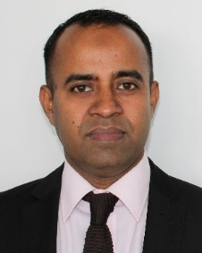
Title: Next generation healthcare device & processing innovation with future networks & systems
Abstract: 5G provides the industry and research community with the privilege to re-think the usages of wireless connectivity. The ultra-reliable low latency communication (URLLC) feature of 5G provides us to consider edge (computing) processing as a service for consumer electronics. Next generation healthcare devices intend to provide more user friendly, reliable & compact user interface depending onto wireless connectivity. Alongside dedicate slice dependency and usage of available free spectrum, privacy & security are few challenges still need to be addressed for wireless connectivity healthcare devices at multi-layer & multi-modal fashion. Without compromising the reliability & security of the data, the devices are also expected to be energy efficient & of low cost. The talk will provide a framework on innovation within next generation healthcare devices to address the above mentioned challenges that 5G & future generation of network can facilitate.

Biography: Mohammad Patwary is currently a Full Professor of Telecommunication Networks and Digital Productivity and the Head of the Intelligent Systems and Networks (ISN) research group at School of Computing and Digital Technology, Birmingham City University, UK. He is also research lead for a world’s first ‘5G Connected Forest’ project - accelerating destination branding for visitor economy in the UK; and has been serving as Principal Data Architect for a multicity 5G testbed in the UK that aims at accelerating digital productivity & develop urban connected community within the UK. He received the B.Eng. degree (Hons). in electrical and electronic engineering from the Chittagong University of Engineering and Technology, Bangladesh, in 1998, and the Ph.D. degree in telecommunication engineering from The University of New South Wales, Sydney, Australia, in 2005. He was with General Electric Company of Bangladesh from 1998 to 2000 and with Southern-Poro Communications, Sydney, from 2001 to 2002, as Research and Development Engineer. He was a Lecturer with The University of New South Wales from 2005 to 2006, and then a Senior Lecturer with Staffordshire University, UK, from 2006 to 2010. He was a Full Professor of Wireless Systems and Digital Productivity and the Chair of the Centre of Excellence on Digital Productivity with Connected Services, Staffordshire University, until 2016. His current research interests include - wireless communication systems design and optimization, signal processing and energy-efficient systems, future generation of cellular network architecture and business modelling for Data-economy.

