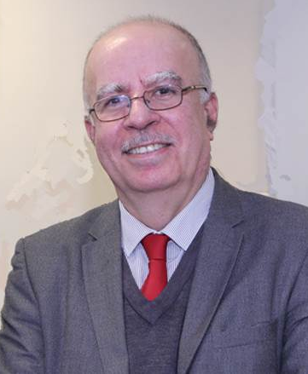
Energy Efficient Radio Frequency Front End System for 5G Mobile Small Cells and beyond
Abstract: This talk presents the model process of the design requirements of the RF front end system that in today´s handset is a key consumer of power. The encompass techniques and functional entities so as to minimize the carbon footprint in mobile handsets devices, whilst providing enabling features for cooperation are detailed towards the energy-efficient operation of multi-standards RF front end for next-generation mobile and wireless communications systems.
It provides the bases of the hardware solutions to the growing RF front-end integration challenges with additional design requirements towards energy efficiency for PAs, tunable filters, reconfigurable antennae. This constitutes four parallel tasks, which will also consider their synergies through collaboration between the academic institutions and the industries. These are:
- Energy efficiency enhancement for RF PAs at both mobile base stations and handsets.
- Reconfigurable RF filter for multimode operation with potential traits towards energy efficiency, good linearity, and potentially low-cost manufacturing over a variety of substrates.
- Reconfigurable array antennas over a wide range of structures of mobile base station and the handsets.
The RF building model proposed here focuses on enabling this technology. Our main research is to enable the implementation of Mu-MIMO at 4G/5G bands for 5G networks to achieve sufficient energy-efficient operation over narrow and wide spectrum for every user.

Biography:
RAED A. ABD-ALHAMEED is currently a Professor of electromagnetic and radiofrequency engineering with the University of Bradford, U.K. He is also the Leader of radiofrequency, propagation, sensor design, and signal processing; in addition to leading the Communications Research Group for years within the School of Engineering and Informatics, University of Bradford. He has long years’ research experience in the areas of radio frequency, signal processing, propagations, antennas, and electromagnetic computational techniques. He has published over 600 academic journals and conference papers; in addition, he has co-authored five books and several book chapters. He is a principal investigator for several funded applications to EPSRCs and the leader of several successful knowledge Transfer Programmes, such as with Arris (previously known as Pace plc), Yorkshire Water plc, Harvard Engineering plc, IETG Ltd., Seven Technologies Group, Emkay Ltd., and Two World Ltd. He has also been a co-investigator in several funded research projects including 1) H2020 MARIE Skªodowska-CURIE ACTIONS: Research and Innovation Staff Exchange (RISE): Secure and Wireless Multimodal Biometric Scanning Device for Passenger Verification Targeting Land and Sea Border Control 2) H2020 MARIE Skªodowska-CURIE ACTIONS: Innovative Training Networks Secure Network Coding for Next Generation Mobile Small Cells 5G-US; 3) Nonlinear and demodulation mechanisms in biological tissue (Dept. of Health, Mobile Telecommunications & Health Research Programme; and 4) Assessment of the Potential Direct Effects of Cellular Phones on the Nervous System (EU: collaboration with six other major research organizations across Europe). He was a recipient of the Business Innovation Award for his successful KTP with Pace and Datong companies on the design and implementation of MIMO sensor systems and antenna array design for service localizations. He is the chair of several successful workshops on energy-efficient and reconfigurable transceivers: Approach toward Energy Conservation and CO2 Reduction that addresses the biggest challenges for the future wireless systems. He is a co-editor for Electronics MDPI Journal since June 2019; in addition, he was a Guest Editor of IET Science, Measurements and Technology Journal since 2009. He has been a Research Visitor of Wrexham University, Wales, since 2009, covering the wireless and communications research areas. His interest in computational methods and optimizations, wireless and mobile communications, sensor design, EMC, beam steering antennas, energy-efficient PAs, and RF predistorter design applications. He is a fellow of the Institution of Engineering and Technology and a fellow of the Higher Education Academy and a Chartered Engineer.

